Library Management System: Requirement Prioritization Using the MoSCoW Method
Course code: CSA1006
Course: Software Engineering
Name: B. Pavani
Register No: 192525248
Tool Used: Microsoft Excel

Aim
To categorize the given Library Management System requirements using the MoSCoW method and justify each category based on its impact on users, feasibility, time, budget and resources.

Software Used
Microsoft Excel (the same workbook can also be opened in Google Sheets).

Concept of the MoSCoW Method
MoSCoW is a method used to decide which requirements should be delivered first. It has four categories:
- Must-Have: Essential for the first release. The system cannot do its main job without it.
- Should-Have: Important, but the first release can still work if it is delayed.
- Could-Have: A useful extra feature, added only if time and resources remain.
- Won't-Have (this release): Not included in this release because of scope, cost or resources. It may be added later.

Procedure

Step 1: Create the workbook
Open Microsoft Excel and create a new workbook. Save it as Library_Management_System_MoSCoW.xlsx.

Step 2: Create the prioritization sheet
Rename the first sheet "MoSCoW Prioritization". Add the columns No., Requirement, MoSCoW Category, Impact on Users and Justification.

Step 3: Enter the requirements
Type the ten requirements given in the question, one in each row.

Step 4: Assign the categories
For each requirement, consider its impact on users and the time, budget and effort needed. Select Must-Have, Should-Have, Could-Have or Won't-Have and write a short justification.

Step 5: Colour the categories
Use a different fill colour for each category (green, yellow, blue and orange) so that the categories are easy to identify.

Step 6: Create the guide and summary sheets
Add a sheet "MoSCoW Guide" explaining each category. Add a sheet "Summary" and use the COUNTIF formula to count the requirements in each category.

Step 7: Save the workbook
Review the entries and save the workbook.

Final Categorization
No. | Requirement | Category | Reason
1 | Search books by title and author | Must-Have | Core function; easy to build with a database search.
2 | Online book reservation system | Must-Have | Lets users reserve books; a basic version is feasible.
3 | Monthly reports on borrowed books | Should-Have | Helpful, but can be built later from records.
4 | Email notifications for overdue books | Should-Have | Reduces late returns; needs email setup.
5 | QR code scanning for borrowing and returning | Could-Have | Speeds up borrowing; needs camera support and testing.
6 | User-friendly dashboard for librarians | Must-Have | Needed for daily work; a basic one is easy to build.
7 | User reviews and ratings | Could-Have | Not needed for borrowing; needs moderation.
8 | Chatbot for user assistance | Could-Have | Needs setup and maintenance; an FAQ page can replace it.
9 | Mobile app version | Won't-Have (this release) | Needs more time and money; a responsive website can serve for now.
10 | Multi-language support | Should-Have | Improves accessibility; can be added in a later release.
Note: The categories are based on a student project with limited time, budget and team size. They may change if the scope or resources change.

Excel Worksheets
The following figures show the three sheets of the completed Excel workbook.
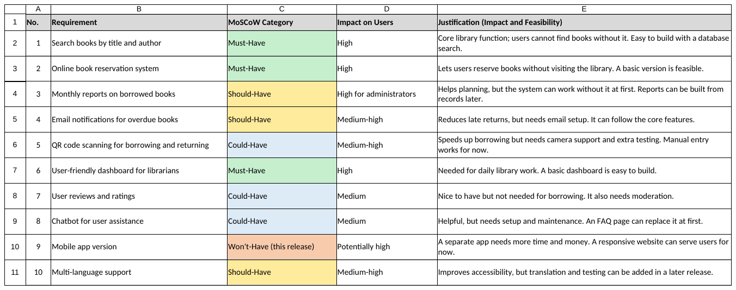
Figure 1: MoSCoW Prioritization sheet
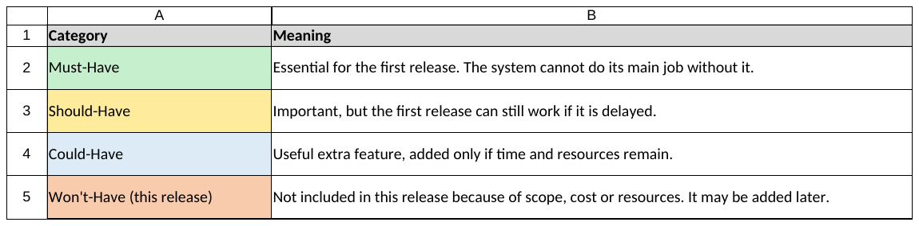
Figure 2: MoSCoW Guide sheet
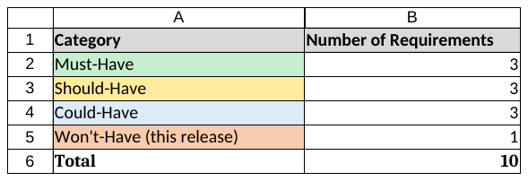
Figure 3: Summary sheet

Result
The ten Library Management System requirements were categorized using the MoSCoW method in Excel. Three requirements are Must-Have, three are Should-Have, three are Could-Have and one is Won't-Have for this release. Each category was justified based on user impact and feasibility.

